NTS415
Zach Brown

Final Project

I followed along with this video and got opnsense set up in vmware. (https://www.youtube.com/watch?v=nJcx_WhbF0M) I was able to connect to it, so I paused the VM. Unfortunately when I resumed it, I could no longer access it in my browser. I tried recreating it from scratch, but it still did not work. I have figured out that even when everything is all set up before it works for me, you have to rename both of the adapters for it to finally work. For some reason, the WAN IP address keeps changing from what I set it to, as it says DHCP4, even though I did not set the WAN IP to DHCP.
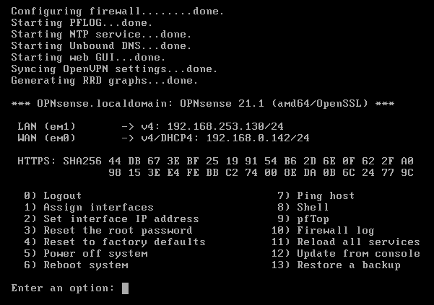
Fortunately it still works, so I was able to connect to OPNSense on my Kali and Windows 10 VM. I could only connect to it through the LAN IP Address, but not the WAN IP Address.

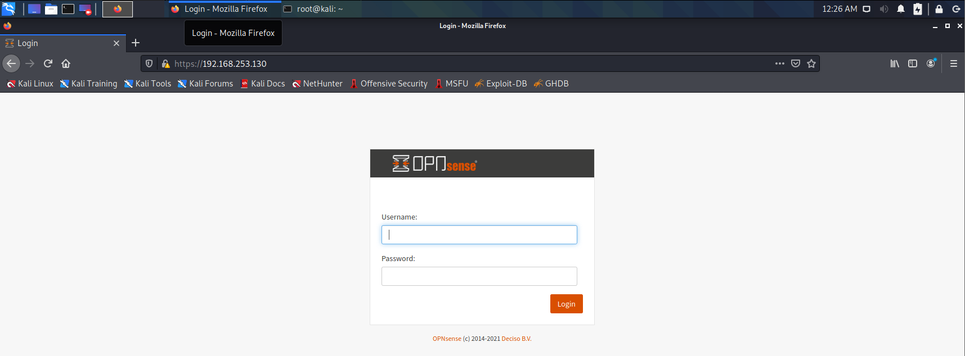
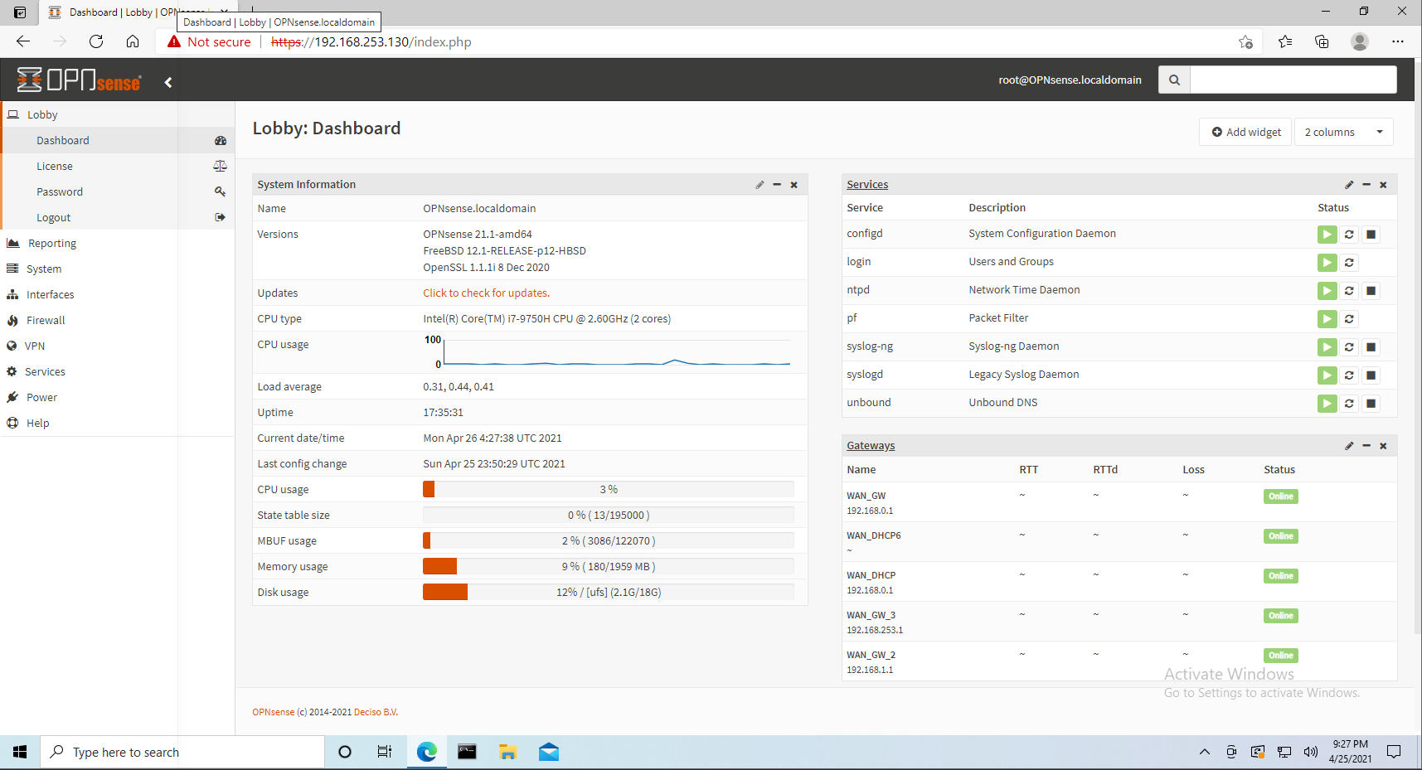
I ran ipconfig on both VM’s and got 192.168.0.138 for Kali, and 192.168.0.148 for Windows.
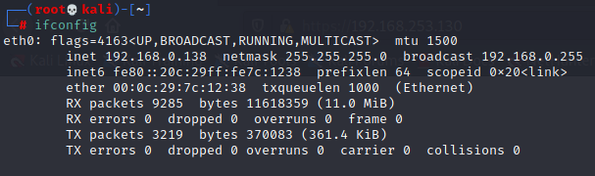

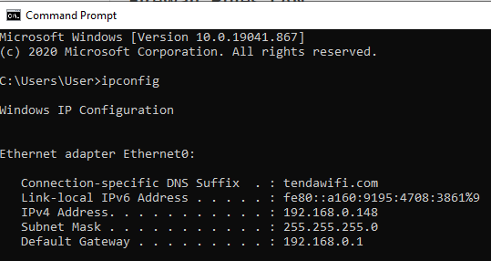
I created a Firewall LAN Rule in order to block the Kali VM IP Address, and deleted the other default rules.
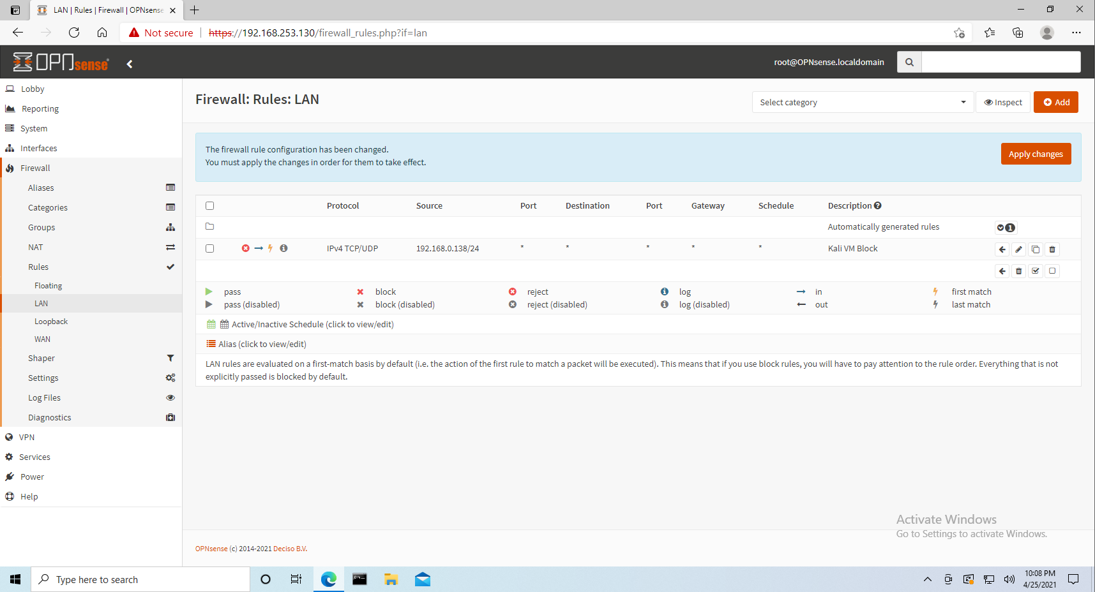

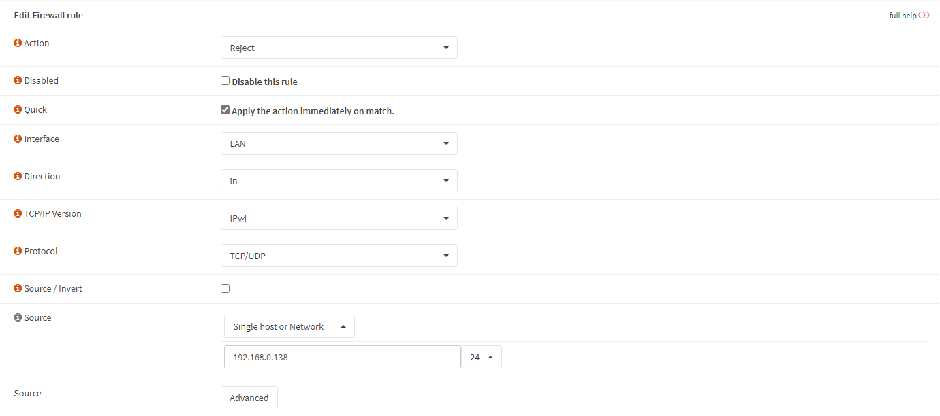
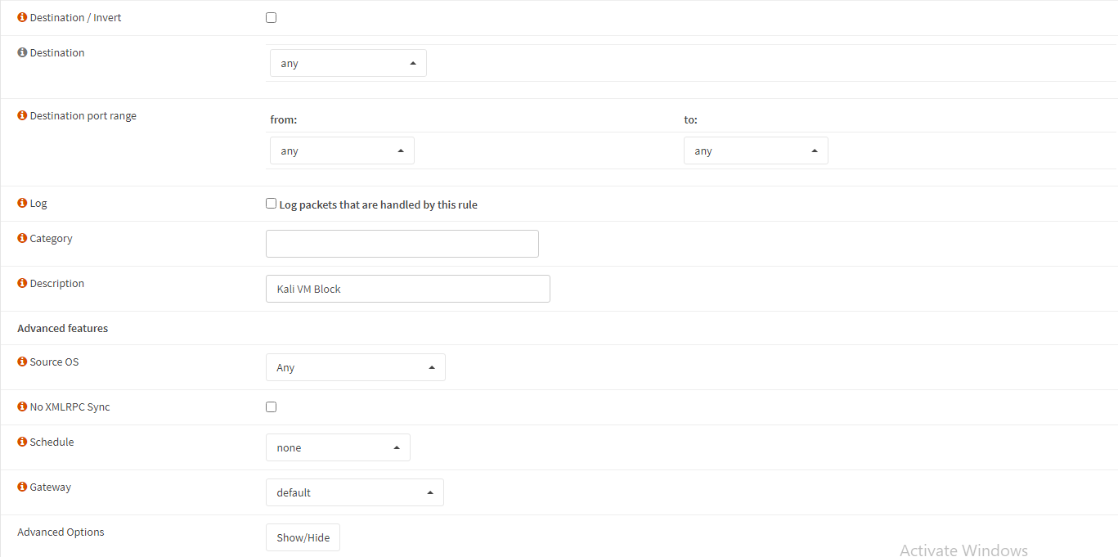
For some reason, this did not block my Kali VM from accessing OPNSense. To show this I had made the rule in the Windows VM, and edited it in the Kali VM.
